PART 1: Initializing the DavisBase CLI – davisql on Google Colab

Starting the main.py and initializing davisql

Implementing help; on davisql>

Implementing init db on davisql>

After the initialization, data directory shows the creation of system_columns.tbl and system_tables.tbl successfully. See the red dotted rectangular marked areas in the following screenshot.

PART2: Test Cases for DavisBaseTeamDeuterium

1. Create table Books, check if books.tbl file created in data folder successfully

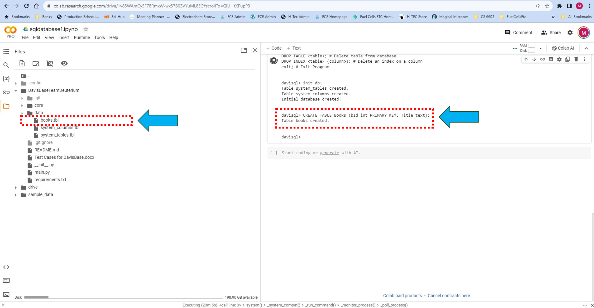

1. Show tables: shows all the tables in the Database

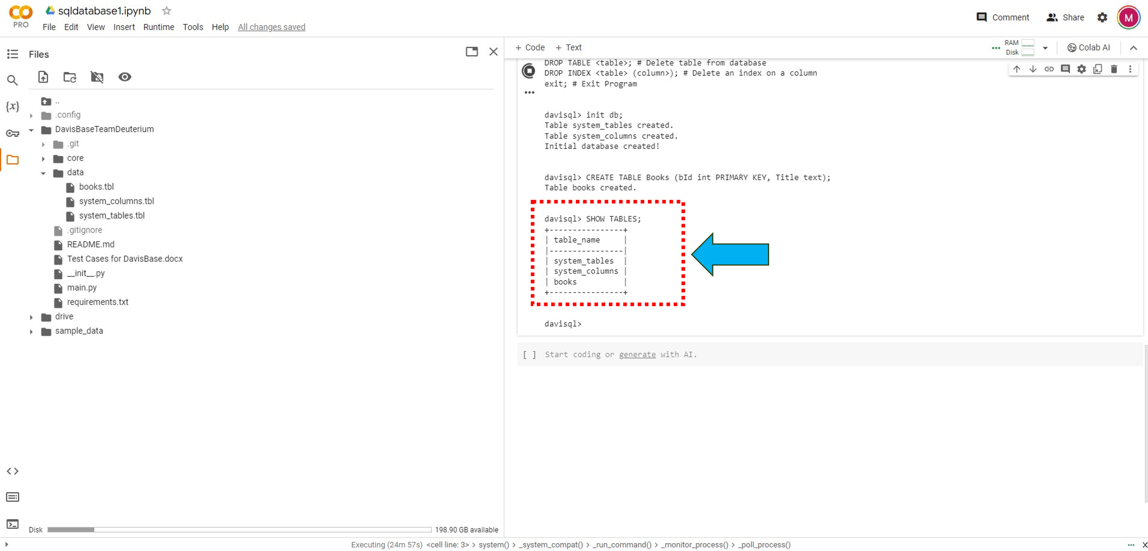

1. Insert values into table books
   1. Check if values inserted in ***‘books.tbl’*** file
   2. Select * from ***‘Books’*** and see if data is displayed successfully
   3. Or select Title, bId from Books and see if data is displayed successfully

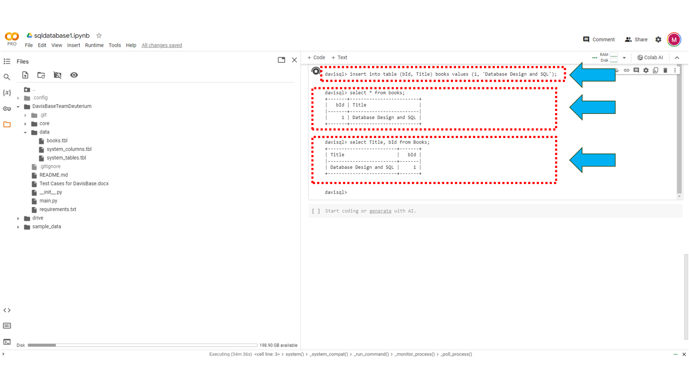

1. Insert values in table ***‘Books’*** by repeating the unique/primary key. Check if appropriate exception is thrown

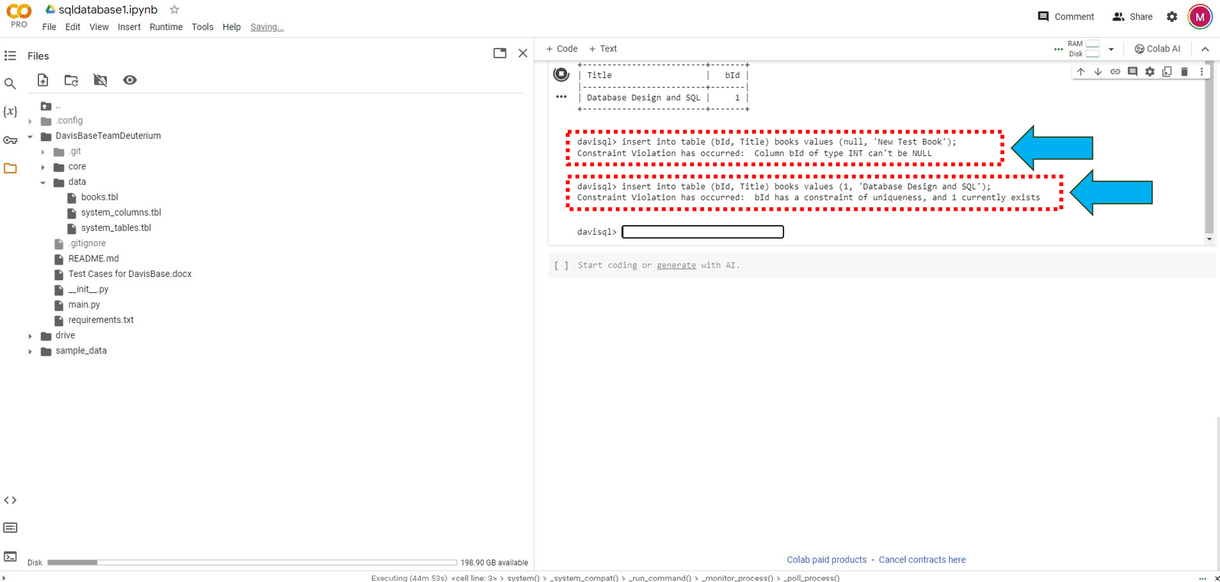

1. Perform Update operation on ***‘Books’*** and check if data is updated successfully

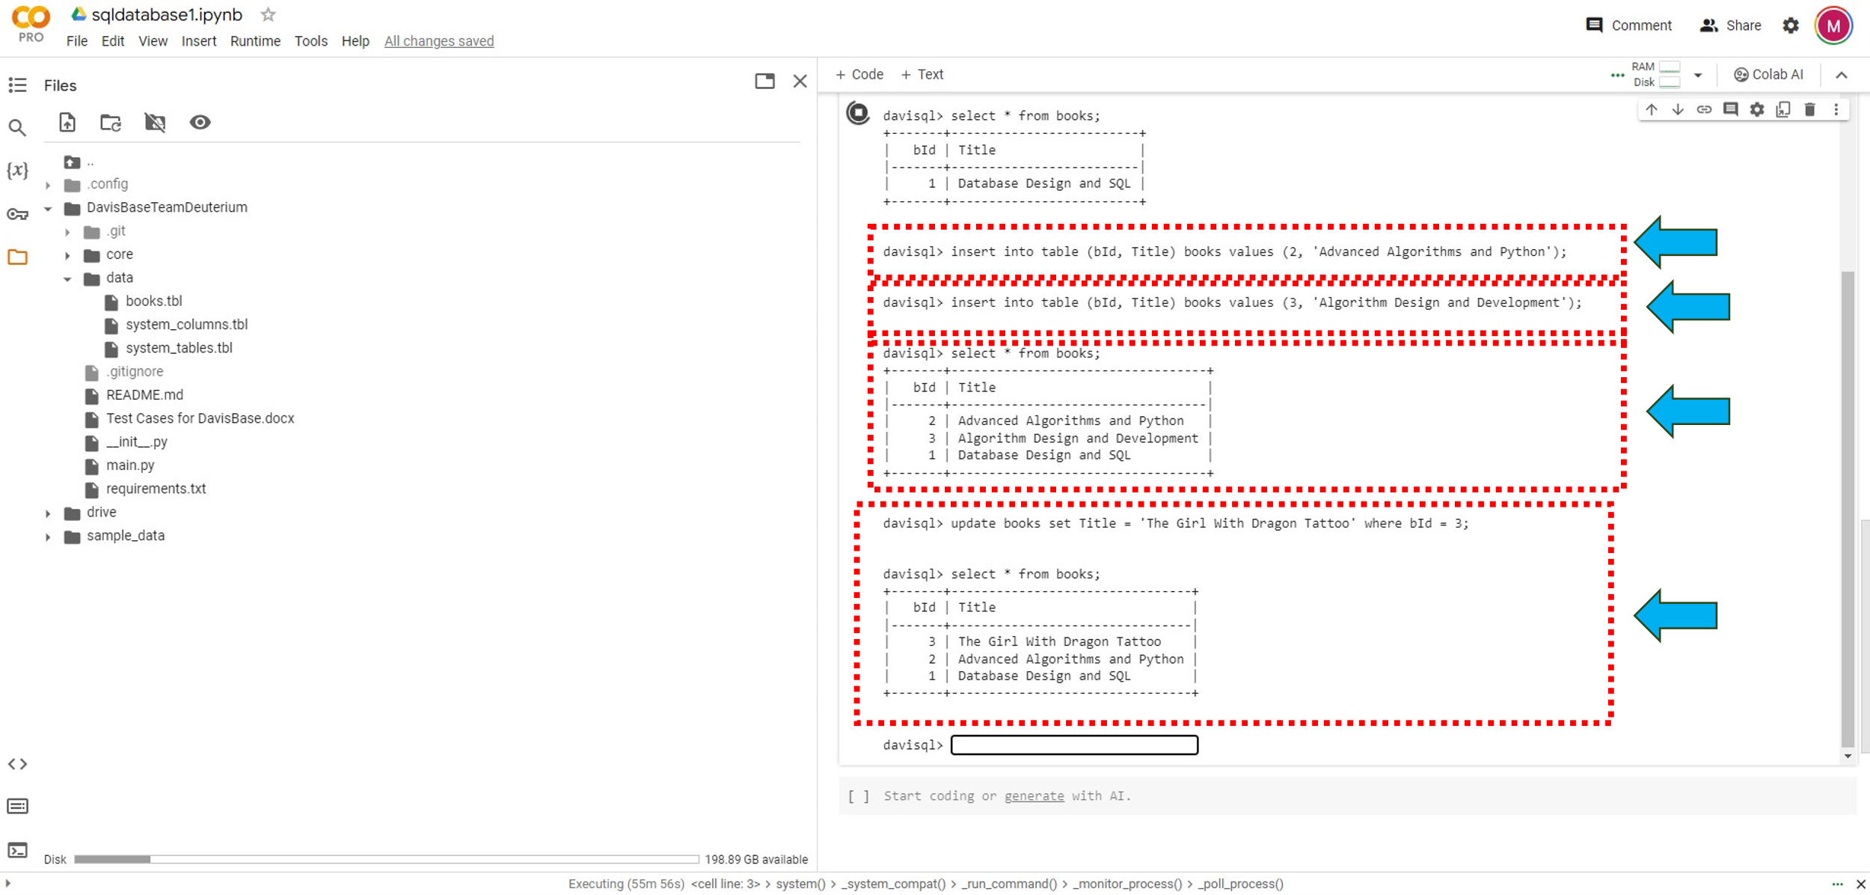

1. Perform Delete Operation

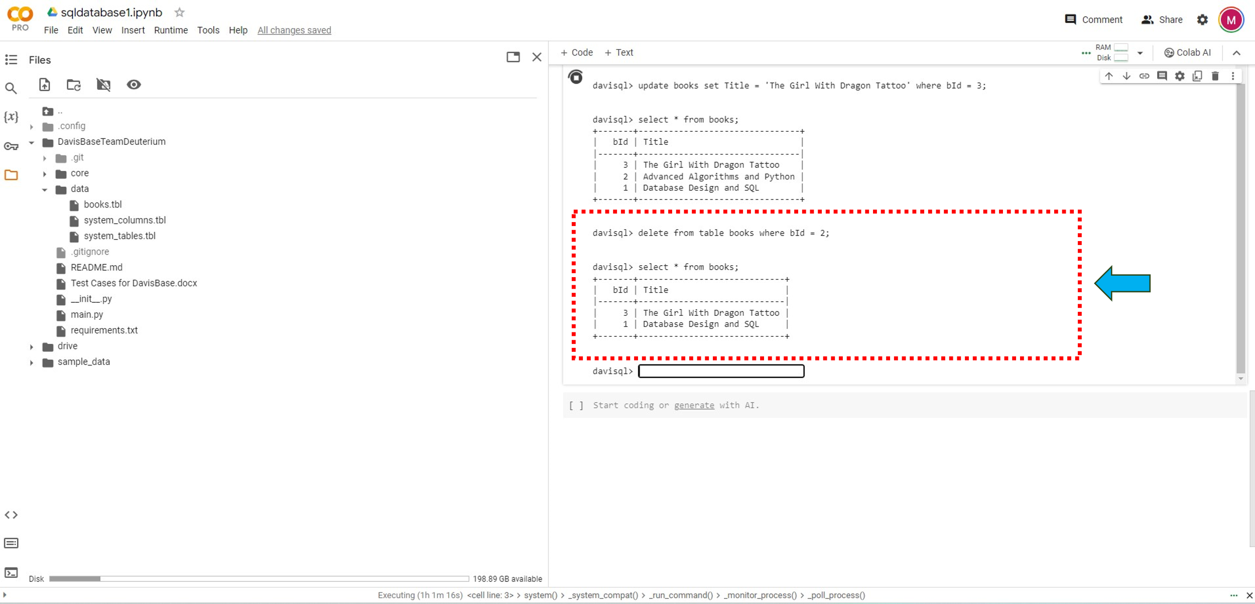

1. Add Index to table books

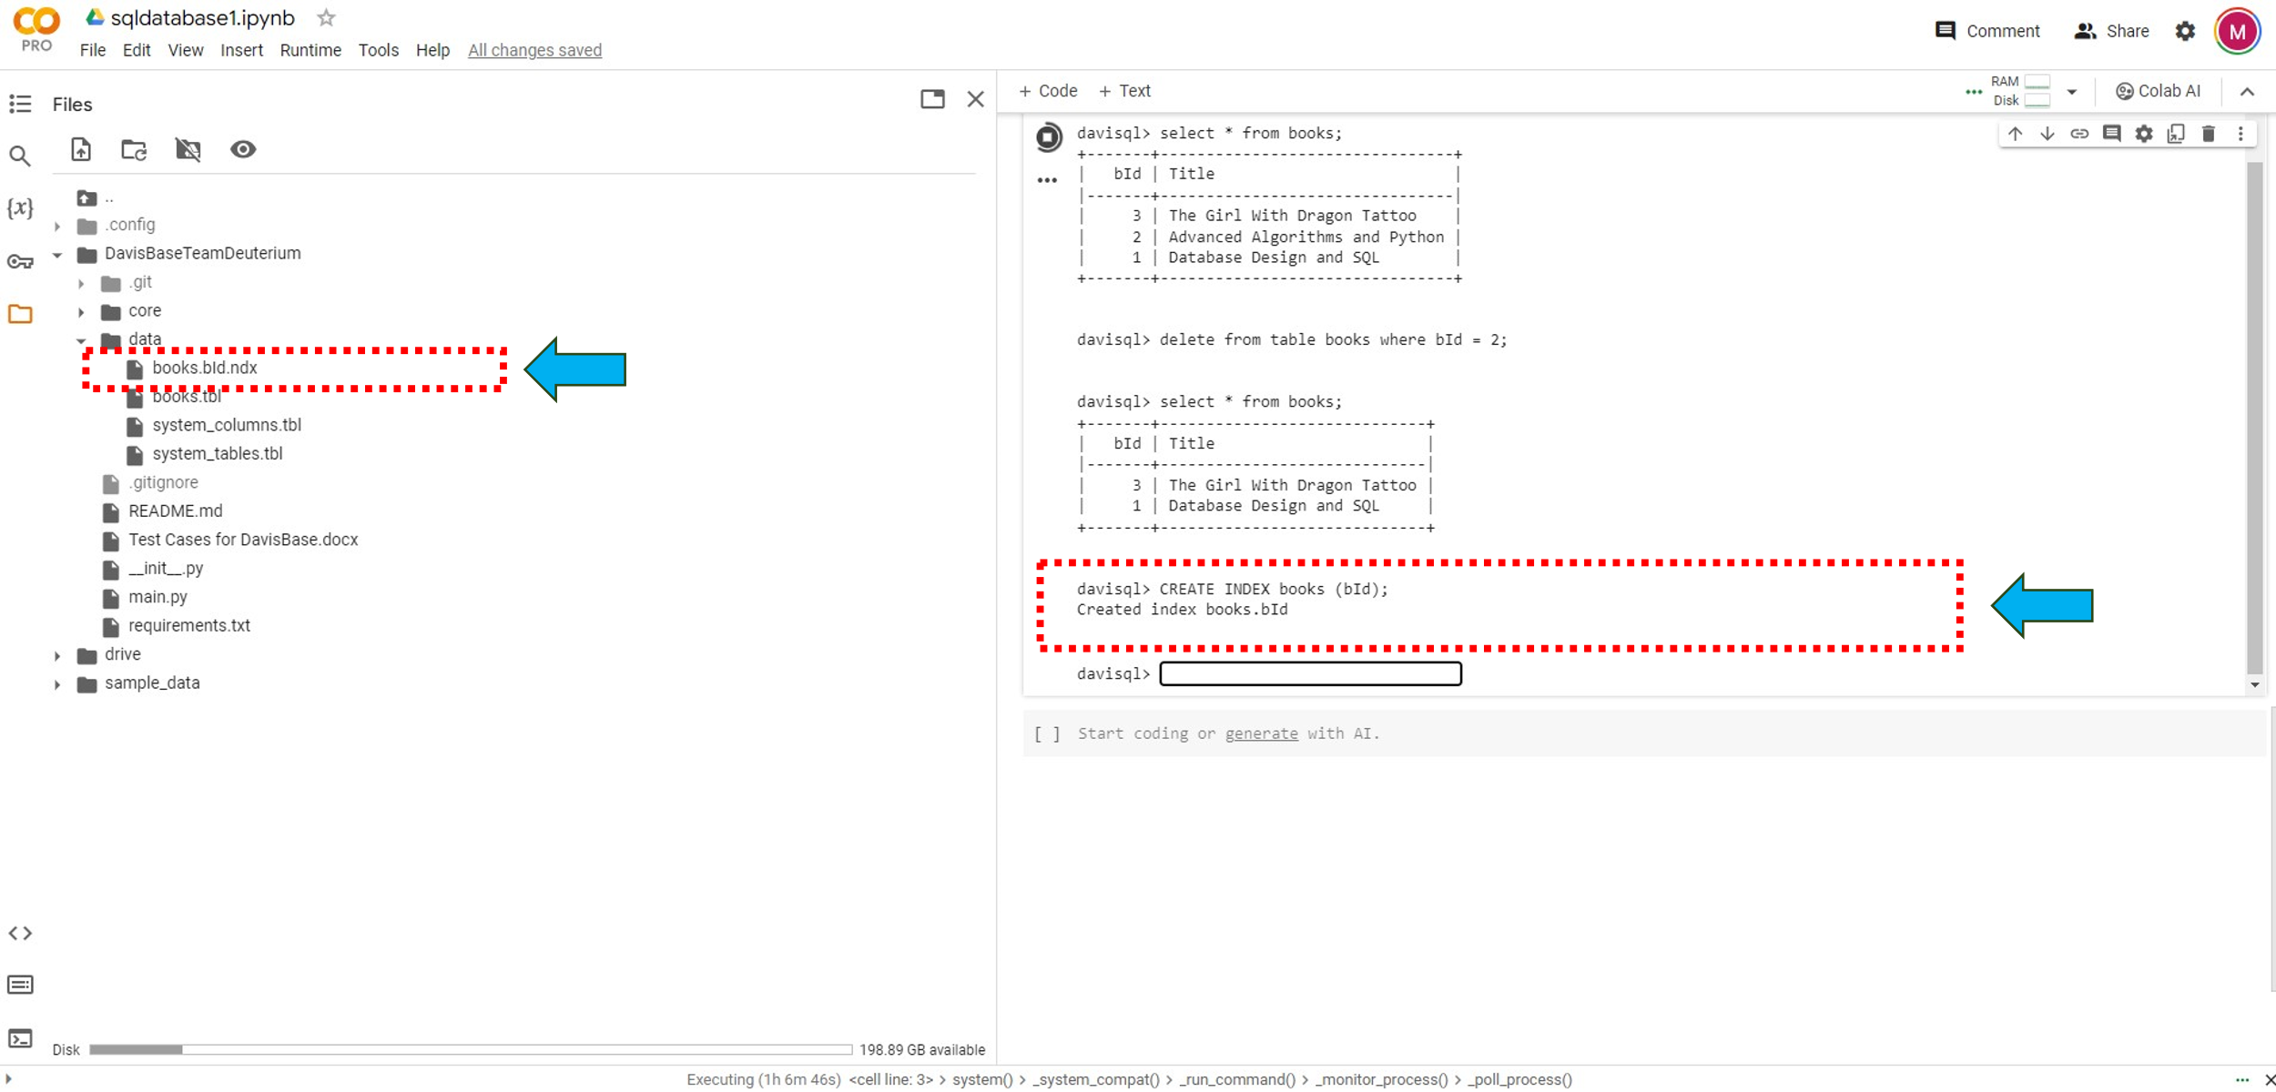

1. Drop Index on table books

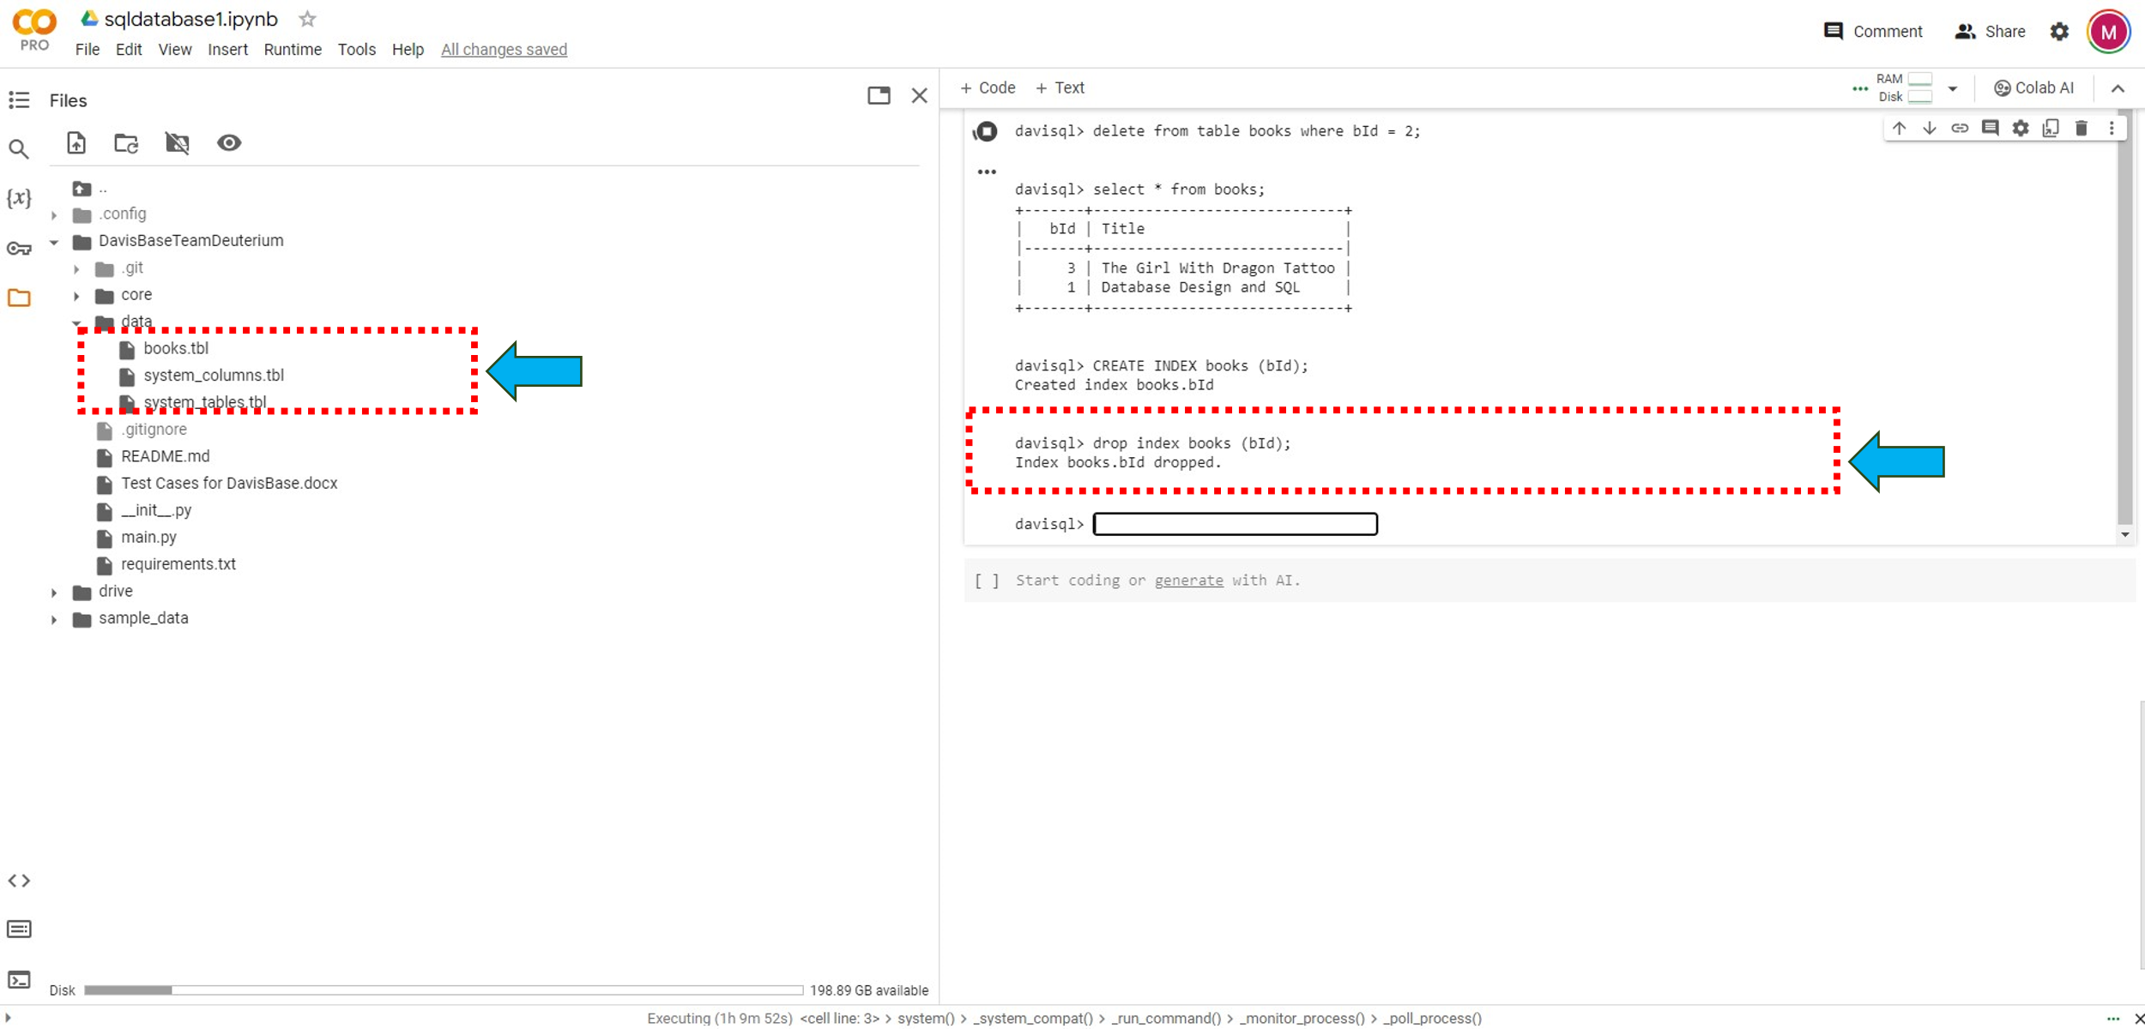

9. Perform Drop Table operation and validate if table is deleted from database and removed from data folder

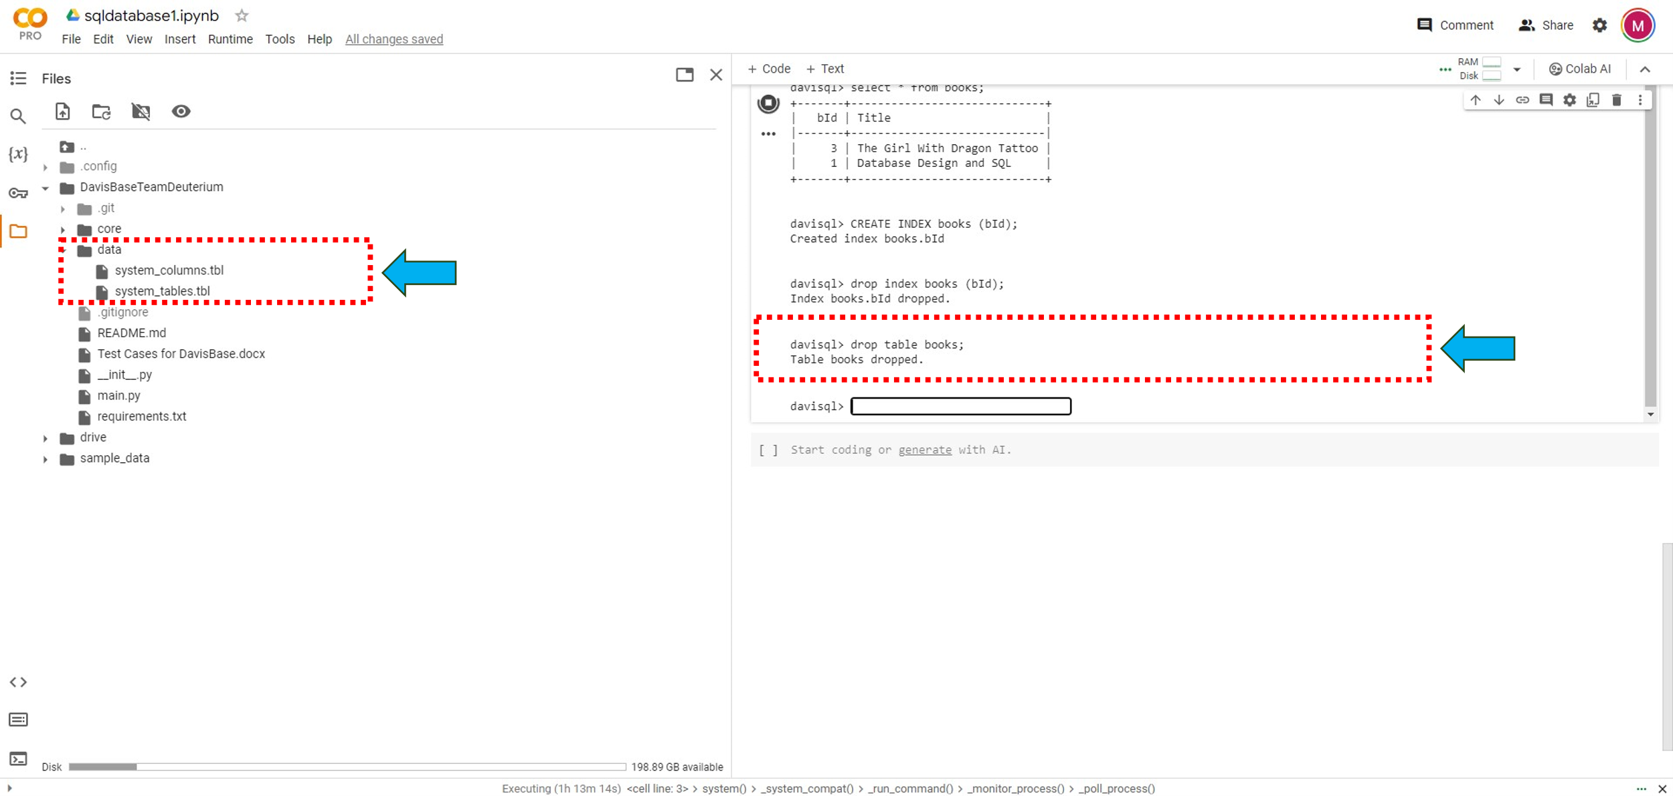

10. select * from system_columns

